**Installation Guide**

The OnlineShop program works on Windows, MacOS and Linux computers. Our program, OnlineShop, has a few items on checklist which must be present in the release folder before you execute the program. The checklist is as follows:

**Prerequisites:**

|  |
| --- |
| 1. Ensure your computer has the latest Java SE/ Java SE Development Kit (JDK) installed |
| 1. Ensure the latest JRE (Java Runtime Environment) is present on your computer |
| 1. Check the files (Products.txt, Trasnactions.txt, Users.txt) are present and are in the right directory (they ought to be in the same directory as the OnlineShop.jar file) The Products.txt and Users.txt file is essential for the program to run as intended. |
| 1. In addition, make sure that the run OnlineShop.bat file is present |

If any of the above system requirements or files are missing, follow the steps below.

**Install a JRE/ Java SE (SDK)**

Please visit the following website and follow all the necessary steps listed to install a JRE/Java SE (SDK) or to update to the latest version.

<http://www.oracle.com/technetwork/java/javase/downloads/index.html>

**Misplaced Text files**

Copy the text files to the same directory as where the OnlineShop.jar file is located

**Missing /Misplaced OnlineShop.bat (Windows Only)**

Please open the text editor (Notepad in Windows)

Copy the following lines to the text editor:

**java -jar OnlineShop.jar**

**pause**

Now save the file as a (filename).bat file and make sure the .bat file is saved to the same directory as the OnlineShop.jar file. Double click the .bat file and Enjoy Shopping!

**Launch Program**

**Windows:**

You may simply double click the .bat file or create a shortcut of the .bat file to desktop and double click the shortcut from there.

**Linux & MacOS:**

Navigate to the directory where the .jar file is. Open terminal and type the following command:

java –jar OnlineShop.jar

The command and output on successfully running the file should look something like the following in Linux & MacOS:

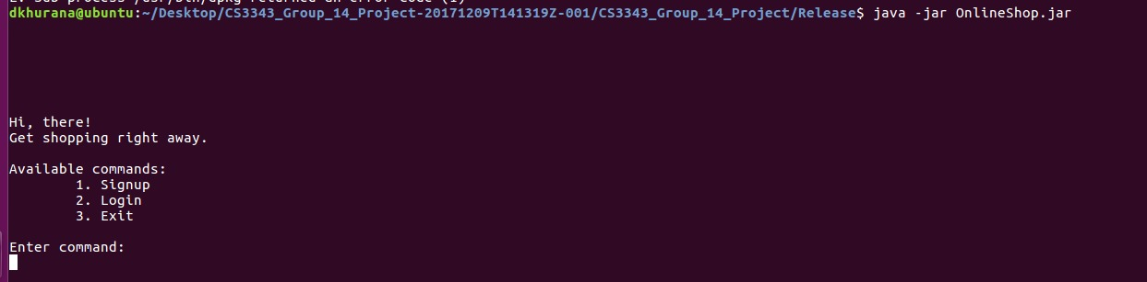

**Refer to the User Manual file / readme.txt for a detailed guide on the usage of the program.**